28.74: At the center of the circular loop the current  generates a magnetic field that is into the page–so the current  must point to the right. For complete cancellation the two fields must have the same magnitude

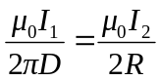

Thus, 